Topology survey   
program guide

# Initialization

Before running the program and importing the data, it is important to make sure that the raw data is in the correct format. We need these data files:

* Coordinates topology text file and topology points excel file
* UU data excel file
* UU drawing (connections) excel file

Please do the following steps to ensure that the data is correctly imported in the program:

1. Coordinates topology text file and topology points excel file
   1. Go to the **DOWNLOAD DATA > TOPO folder**
   2. Go through each folder and verify the following:
      1. The coordinates topology text file and topology points excel file both have the same number of data points.  *For example:*

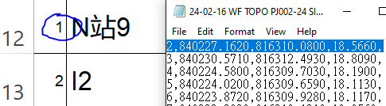 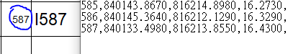

*In this case, the TOPO excel file starts at number 1 and ends on 587 whereas the coordinates text file starts at number 2 and ends on 587. So a dummy coordinate for number 1 should be added to the coordinate text file so that it matches with the TOPO excel file.*

***IT IS CRUCIAL TO VERIFY THAT THE EXCEL AND TEXT FILE BOTH HAVE MATCHING ROWS OF DATA.***

* + 1. Once it is assured that the text and topo files are matching, rename the files (AND THE CONTAINING FOLDER) according to the following format:

**[Project Date] [Supervisor] [File Type] [Project Number] [Site Name] [File Number]**

(e.g. 24-01-12 MF TOPO PJ002-24 siteB 3)

(e.g. 23-10-11 MF COORD PJ001-23 siteD 1)

1. For UU data excel file
   1. Go to the **DOWNLOAD DATA > UU** folder
   2. Rename all the excel files according to the following format:

**[Project Date] [Supervisor] [File Type] [Project Number] [Site Name] [File Number]**

(e.g. 24-02-14 WF UU PJ002-24 siteA 1)

* 1. Next, make folders based on the site name and put the excel files inside those folders accordingly.

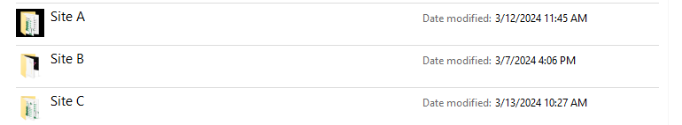

1. For UU drawing (connections) excel file
   1. Open a new excel file.
   2. Make the connections according to the site sketch. NO NOT HAVE PAGE NUMBERS in the excel sheet, only the connections. Also, make sure that each row DOES NOT EXCEED 20 cells. If it does, then continue the connection in the next line, starting with the ending point in the previous line.



* 1. Once you make the excel connection file, go to **Survey Reports** folder and make folders based on the site name and put the excel files inside those folders named **Drawing Line** **[Project Number] [Site Name]**.

(e.g. Drawing Line PJ002-24 SiteA)



* 1. Save the excel connection file in the corresponding site folder in **Survey Reports**.

# Starting the program

1. Take the automated Topo_Housing_Auto_v5.4.6J or Topo_General_Auto_v5.6.10 template according to the type of project and make a copy of it in the **Survey Reports > [Site Name]** folder.
2. Open the Topo_Housing_Auto_v5.4.6J/Topo_General_Auto_v5.6.10 template excel file.
3. Go on the first sheet of excel file called **AutoImport** sheet and click on the **Open Copy Data Program** button. It should look like this:

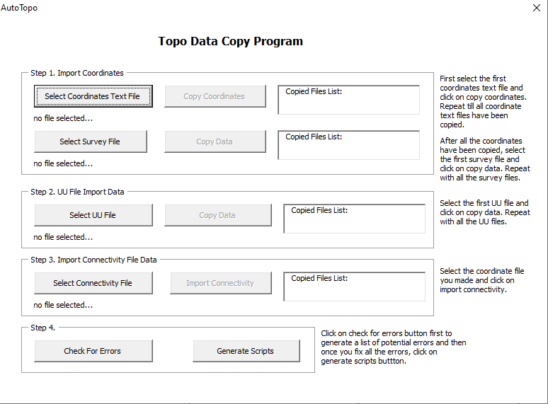

# Step 1. Import Coordinates

1. Click on **Select Coordinates Text File**, browse to the text file in ***DOWNLOAD DATA > TOPO*** folder, and click on **Copy Coordinates**. If you have multiple coordinates files for the same site, repeat this step on all the text files till all coordinate text files have been copied.
2. Click on **Select Survey File**, browse to the TOPO excel file in ***DOWNLOAD DATA > TOPO*** folder, and click on **Copy Data**. If you have multiple TOPO excel files for the same site, repeat this step on all the TOPO excel files till all the TOPO excel files have been copied.
3. NOTE: The selected file will show in below the **Select Coordinates Text File** button and once copied, it will show in the list box. DO NOT COPY THE SAME FILE AGAIN AND AGAIN.

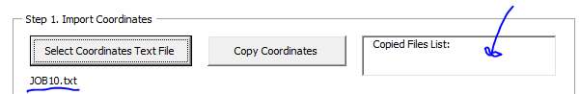

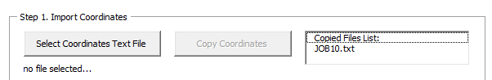

# Step 2. UU File Import Data

1. Click on **Select UU File**, browse to the UU excel file in ***DOWNLOAD DATA > UU*** folder, and click on **Copy Data**. If you have multiple UU excel files for the same site, repeat this step on all the UU excel files till all UU excel files have been copied.
2. NOTE: The selected file will show in below the **Select Coordinates Text File** button and once copied, it will show in the list box. DO NOT COPY THE SAME FILE AGAIN AND AGAIN.

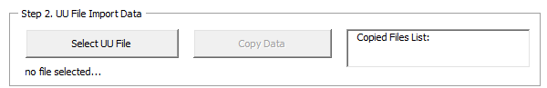

# Step 3. Import Connectivity File Data

1. Click on **Select Connectivity File**, browse to the connectivity excel file that you made in and put in the **Survey Reports > [Site Name]** folder, and click on **Import Connectivity**. Since there should be only one connectivity file, you should not repeat this step.
2. NOTE: The selected file will show in below the Select Coordinates Text File button and once copied, it will show in the list box. DO NOT COPY THE SAME FILE AGAIN AND AGAIN.

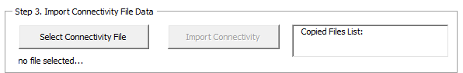

# Step 4.1 Check for Errors

1. Click on **Check For Errors** button and let the program run. Once it finishes, ask a UU drawing maker to check the errors in the excel file.
2. The basic errors will be displayed in the table on the **AutoImport** sheet.

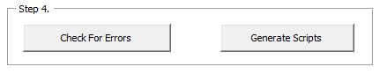

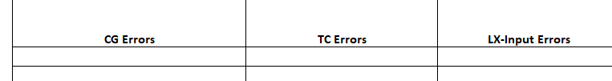

OPTIONAL: Set Site Number Program

After ALL THE ERRORS ARE SOLVED, IF THERE ARE MULTIPLE SITES, close the **Copy Data Program** and open the **Set Site Number** program.

1. On the **AutoImport** sheet, click on **Set Site Number** button.
2. Select the site number. For example, Site A = 1, Site B = 2, etc.
3. Click on **Set Site Numbering**.

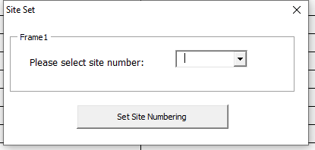

# Step 4.2 Generate Scripts

1. Once everything is done, in the **Copy Data Program**, click on Generate Scripts button.
2. Browse to the **Survey Reports > [Site Name]** folder in the dialog box, and create a new folder there called **scripts**. Double click and open the empty **scripts** folder in the dialog box. Click on the **OK** button to save the scripts there.

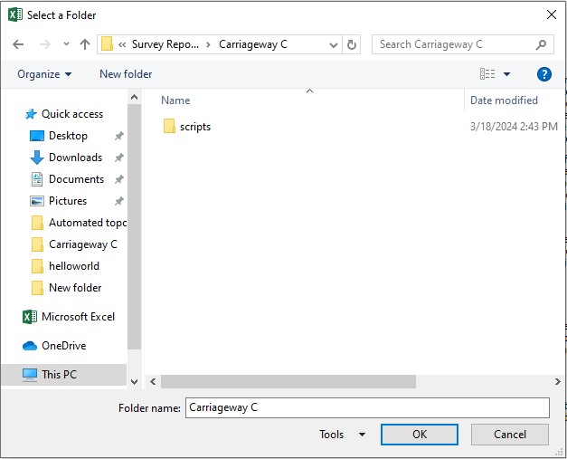

# ADDITIONAL STEPS FOR HOUSING PROJECTS

If the project is housing and you are using the Topo_Housing_Auto_v5.4.6J file, you need to do some additional steps for generating the GPR script. After generating the main scripts, do the following:

1. On the **AutoImport** Sheet, click on the Open GPR Program button.
2. Click on **Import R Points** button.
3. Click on **Generate Scripts** button.
4. Browse to the **Survey Reports > [Site Name] > scripts** folder in the dialog box, Click on the **OK** button to save the scripts there.

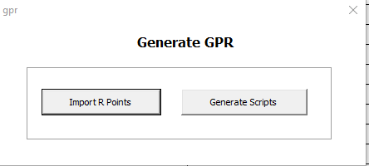

# ERROR CHECK FOR DRAWING MAKERS

1. In sheets CG and TC the **red highlighted cells mean duplicates** and **yellow highlighted cells means the added dummy values** which the program added when it checked for errors in the data.
2. For the error table in AutoImport sheet, the **yellow highlighted cells mean no changes were made for this error by the program**. Those errors are just for reference.